Jordan Roberts

August 12, 2020

BAN 530

Decision Analysis

In late 2019, an outbreak of a novel coronavirus was reported in China. COVID-19, the disease resulting from the viral infection, soon spread outward to other countries via human-to-human transmission. By January 22, 2020, the US saw its first case as 6 countries reported infections. Within one month, 30 countries had been infected, and within two months 168 had at least one confirmed COVID-19 case. The rapid spread shocked the world and has caused global economic downturns as countries have shut down activities and borders. Some of the issues affecting response to the virus include poor leadership, lack of resources, and general misinformation about the pandemic.

This project aims to identify the countries and individual US counties that struggled the most with the handling of this global emergency. I have used six datasets detailing the spread of the coronavirus from January 22, 2020 to June 23, 2020, a period of 154 days. One dataset depicts the US’s situation by county, and the other five deal with country-based data. The county dataset and three of the country datasets detail daily confirmed cases, deaths, recoveries, and currently active cases, while the final two give summary data from the final day of record.

Important to note is that actual numbers of infected people are different from the recorded numbers. Testing resources were (and still are in many places) in short supply globally, so many infected went untested while many others contracted the virus but never exhibited any symptoms. As the incubation period for the coronavirus can be up to two weeks long, one infected person could have infected countless others without knowing it. This project deals only with recorded numbers.

**Preliminary Analysis**

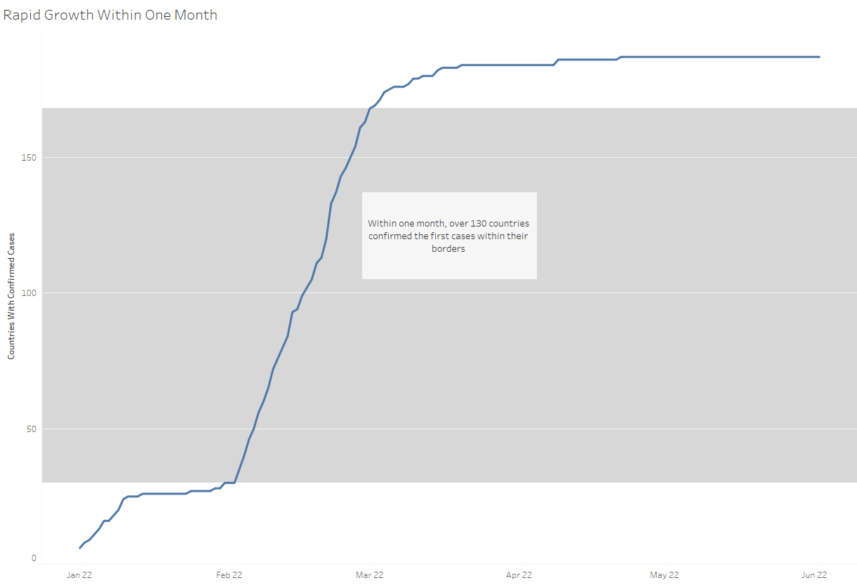

There was a sharp increase in the number of countries confirming cases from February to March. Many countries did not take the situation seriously due to lack of information or plain misinformation. Travelers continued vacationing and visiting various countries during the early stages of the infection. Even after countries began to take things seriously, due to the incubation time infected people who were believed to be “contained” within a country’s borders had already infected people prior.

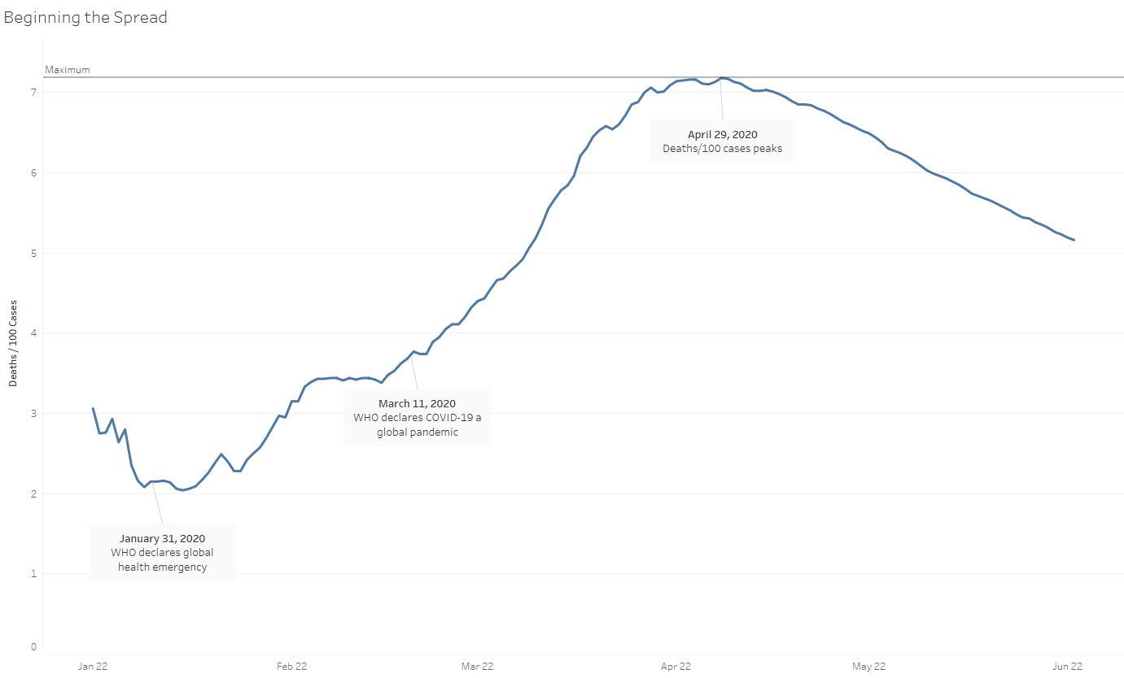

We can see here the runaway death toll from early March to late April. Partly due to lack of medical resources (overcrowded hospitals, insufficient numbers of ventilators and testing packs, etc.), the death toll rose rapidly even as more cases were being identified.

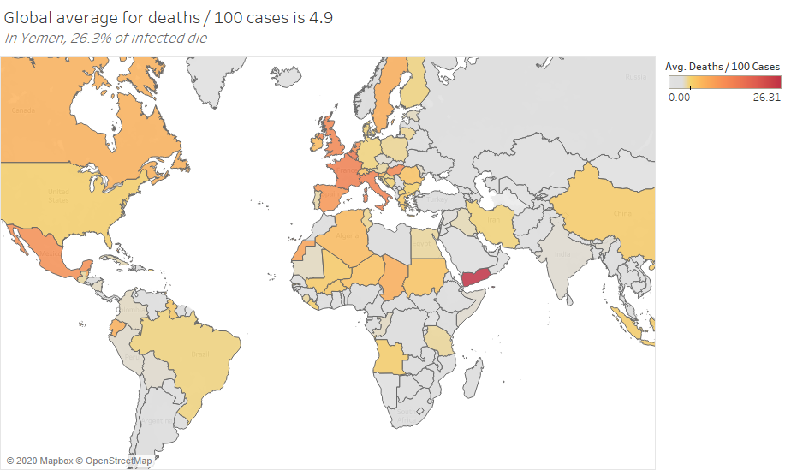

Some countries had notably worse response rates than others, leading to high death tolls in certain regions and relatively low ones elsewhere. Much of Africa was spared from COVID’s wrath in comparison to the rest of the world. Interestingly, Asian countries also managed to contain the pandemic. This is due in part to national collectivism and previous experience with viral outbreaks (the SARS and bird flu epidemics from the early 21st century were still fresh wounds).

The Americas and Europe, when adjusted for population, had by far the worst death tolls. This is a trend we see repeatedly in our data.

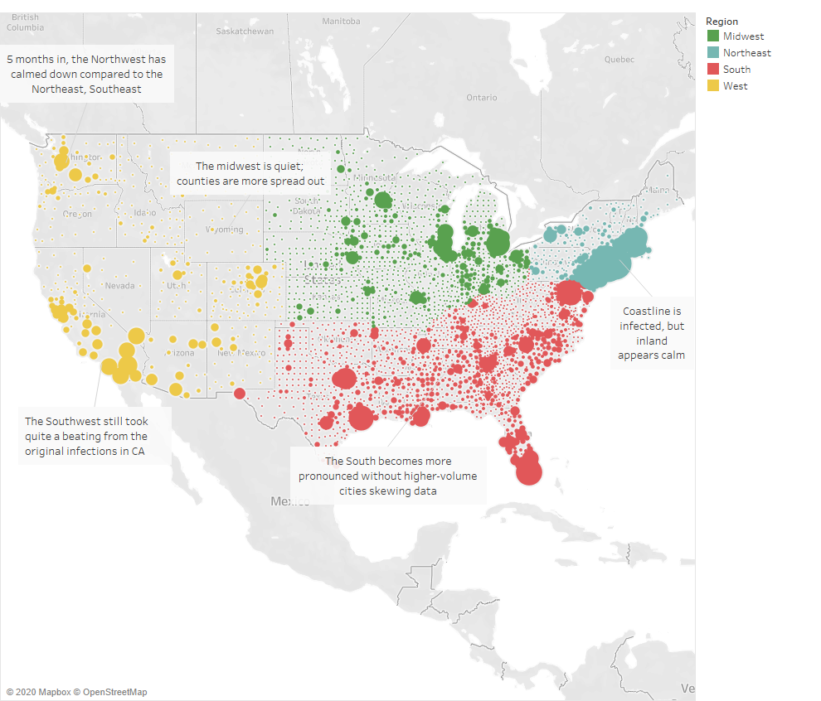

In the US, our county data shows an interesting story. I removed from the data New York City, Los Angeles, and Chicago, the three most populous cities in the US. These three cities (and the counties in which they reside) had such high case numbers that they skewed the data. Without them, there is a more useful picture of the pandemic. The northeast has a great deal of infections spilling outward from NYC, but the South picked up in numbers toward the end of our dataset. Infections are concentrated around major population centers while counties that are spread apart, like those in the Mid- and Northwest, had few if any cases. The human-to-human transmission was effective in tighter communities.

**Decision Analysis**

It is believed that the first cases were transmitted from animals to human, but the spread of COVID-19 was mainly due to human-to-human transmission. Some of the suggested measures provided by the WHO and the CDC were social distancing, shutdowns of nonessential businesses, and other factors to reduce contact between humans. Many national and local governments were slow to adopt these policies, and they were largely the hardest hit. In South America, much of the population exists as “working poor”, surviving from paycheck to paycheck and unable to afford necessities that allow them to stay at home for extended periods. Many in Eastern Europe are the same.

All over the world, health systems failed to provide the needed care for the huge influx of patients. Ventilator shortages are still common, and medical staff are reportedly overworked and understaffed globally. Some countries closed their borders in large part due to an influx of extra-nationals escaping their own failing medical system. Government responses were slow in countries like Belarus and Brazil, and many downplayed the pandemic even late into their own infections.

The main areas of the world that struggled containing the virus were the Americas and Europe. Europe waited some time to close borders, and travel is especially easy and encouraged within the European Union. This led to higher case numbers. Similarly, travel is easy and encouraged within the US, where the top areas for case numbers and deaths were the Northeast and the South. States were given free reign to decide on safety measures, and many opened early or closed late. This also led to higher case numbers.

In North and South America, my models predict that countries reach the runaway period of COVID cases around 9,000 cases with no recoveries. Recoveries raise this number somewhat, but once a country nears this level, deaths rise as healthcare systems are overloaded and resources run dry. In Europe, 7,000 cases with no recoveries is the critical level. These numbers are likely to be higher, however, due to the long incubation period of the coronavirus. Before these levels are reached, more serious measures need to be taken to slow the growth.

National and local governments should be enforcing social distancing measures harshly, as these are the best defense against human-to-human transmission. Everyone’s economy has taken a hit from the pandemic, but the situation is only being made worse by more spikes in cases, which result in longer infection periods. In support of this, governments should also be providing stimulus checks to those who need them (small businesses, unemployed, etc.) so that people can afford to stay home for longer periods.

**Issues**

No one can tell a government how to run its community. In the end it is up to individual leaders and their cabinets to decide the best course. The 21st century has seen a rise in the use of misinformation to mislead the general public, and a distrust in science has exacerbated this. Leaders in the Americas and Europe, as well as elsewhere in the world, have denied scientific consensus and thus doomed their populations to suffer the predicted consequences. This ultimately leads to spikes in cases as people are less concerned about the pandemic and become sick, overburdening an already underprepared health system that cannot procure the resources necessary to provide proper care.

Worldwide shortages of testing kits, ventilators, and other medical supplies also made the pandemic worse than it could have been. Many people have died during the pandemic that might have lived had there been enough room for them in hospitals while COVID patients were being treated. Vaccines and supplies have been fought over by competitive buyers, meaning that fewer people can actually access the resources that do exist. Quarrels between and among nations have impeded the grand scheme of providing help to those affected most, and this is not something easily fixed.

Another issue is with the data itself. Many countries (such as China and Russia) have been accused of falsifying data in order to produce a better image. This competitiveness and lack of transparency only hurts the world, as adequate plans cannot be made with inaccurate data. Every case that goes unreported hides valuable tools from the world stage, leading to higher levels of unpreparedness. The fear of losing economic footholds also keeps numbers in the dark, as no one wants to come out of the pandemic in a worse spot than before. Economies open back up under false pretenses, promoting a healthy image while getting more people sick.